# Matrix Plots

Matrix plots allow you to plot data as color-encoded matrices and can also be used to indicate clusters within the data (later in the machine learning section we will learn how to formally cluster data).

Let's begin by exploring seaborn's heatmap and clutermap.

## Heatmap

In order for a heatmap to work properly, your data should already be in a matrix form, the sns.heatmap function basically just colors it in for you.

We can see, by .corr(), a matrix was formed and seaborn has filled color according to some number scale.

import seaborn as sns  
import matplotlib.pyplot as plt  
import pandas as pd  
tips = pd.read_excel("C:/Users/G01212601/Desktop/dataFrame.xlsx")  
flights = pd.read_excel("C:/Users/G01212601/Desktop/Flights.xlsx")  
tc = tips.corr()  
print(tc)  
sns.heatmap(tc)  
plt.show()

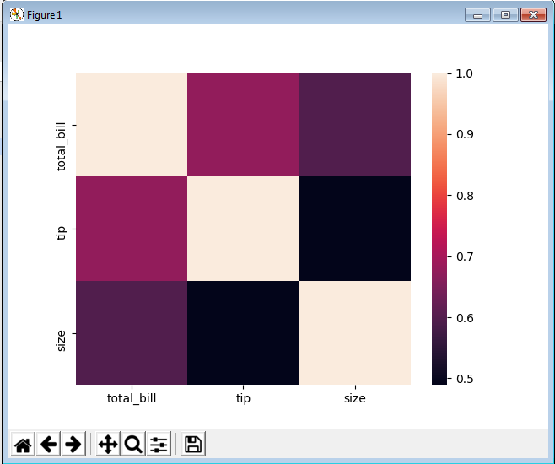

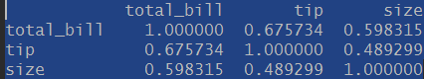

We can also print the values by specifying the annot argument.

import seaborn as sns  
import matplotlib.pyplot as plt  
import pandas as pd  
tips = pd.read_excel("C:/Users/G01212601/Desktop/dataFrame.xlsx")  
flights = pd.read_excel("C:/Users/G01212601/Desktop/Flights.xlsx")  
tc = tips.corr()  
sns.heatmap(tc,annot=True)  
plt.show()

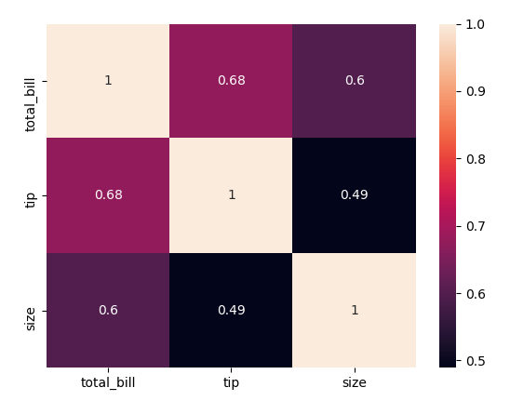

We can also add color map argument as –

sns.heatmap(tc,annot=True,cmap="coolwarm")

For flights data set, we converted the data frame into a pivot table so that we get a matrix which corresponds to our data points.

import seaborn as sns  
import matplotlib.pyplot as plt  
import pandas as pd  
tips = pd.read_excel("C:/Users/G01212601/Desktop/dataFrame.xlsx")  
flights = pd.read_excel("C:/Users/G01212601/Desktop/Flights.xlsx")  
print(flights.head(5))  
fpt = flights.pivot_table(index="month",columns="year",values="passengers")  
print(fpt.head(5))  
sns.heatmap(fpt,cmap="coolwarm")  
plt.show()

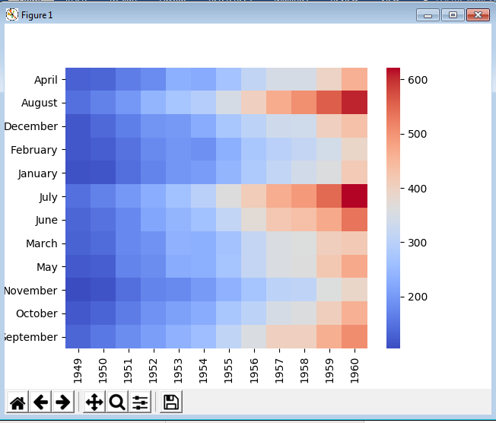

Below we can see the data before and after the pivot table application-

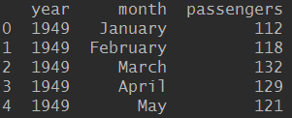

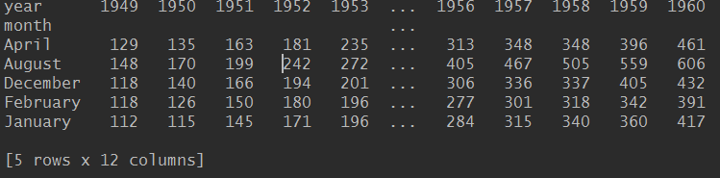

We can also add line color and line width

import seaborn as sns  
import matplotlib.pyplot as plt  
import pandas as pd  
tips = pd.read_excel("C:/Users/G01212601/Desktop/dataFrame.xlsx")  
flights = pd.read_excel("C:/Users/G01212601/Desktop/Flights.xlsx")  
print(flights.head(5))  
fpt = flights.pivot_table(index="month",columns="year",values="passengers")  
print(fpt.head(5))  
sns.heatmap(fpt,cmap="coolwarm",linecolor="black",linewidths=1)  
plt.show()

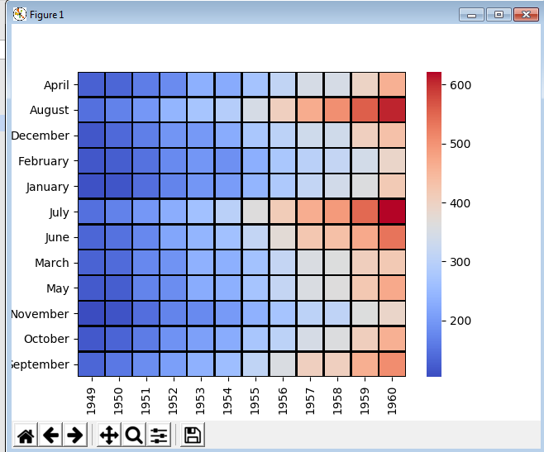

## clustermap

The clustermap uses hierarchal clustering to produce a clustered version of the heatmap.

import seaborn as sns  
import matplotlib.pyplot as plt  
flights = sns.load_dataset("flights")  
fpt = flights.pivot_table(index="month",columns="year",values="passengers")  
sns.clustermap(fpt)  
plt.show()

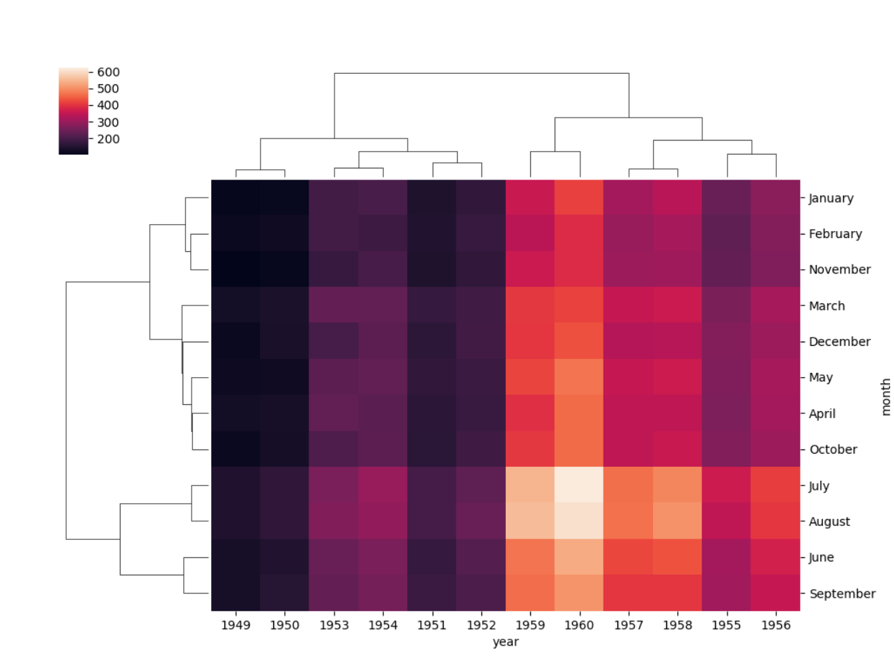

We can specify cmap for colour scheme and standard scale for scale till 1

import seaborn as sns  
import matplotlib.pyplot as plt  
flights = sns.load_dataset("flights")  
fpt = flights.pivot_table(index="month",columns="year",values="passengers")  
sns.clustermap(fpt,cmap="coolwarm",standard_scale=1)  
plt.show()

